Dheeraj
Written task
5SVM

Part 1 Language in Cultural Context

Title : Portrayal of Racial Discrimination and Financial Inequality of African Americans

Topics: Language and Power
Language and Identity

Text Type : Interview

Source Text : “Story Of O.J.” by Jay Z

Rationale word count : 299 words
Task word count: 997

Rationale

As part of culture and identity topics under language and cultural context, I learnt how speeches and songs play a significant role in tackling different social issues. This inspired me to analyse the context of the song “Story of O.J ‘ written by singer and songwriter, Jay-Z. This song depicts issues on financial inequality and racial discrimination against Black Americans by featuring O.J’s life story in the lyrics of the song. Hence I chose to write an interview of Jay Z to bring out his sentiments and his reasons behind the lyrics of this song. The interview is to be published in a music magazine “Billboard’ read by music enthusiasts and musicians who are likely to be subscribers to the magazine. This text type is effective as it directly conveys the opinions of featured individual on specific social issue to a specific audience.

The task takes the perspective of Jay Z whose songs are influenced by his past experiences of drugs and gang activities which are heavily linked to Black Americans like himself and O.J. This interview targets fans of Jay Z and those reader who can relate to the issues of discriminations and financial injustices of the Black Americans. Specifically, the text aims to raise awareness on discrimination of Black Americans and other races due to wealth and race in hope to reduce the oppression of these people and challenge the perception and change culture in America

To achieve these purposes, the text uses music jargons and colloquial language to relate to its target audience. Also, question and answer format and informal tone is used to imitate the way the Jay-Z speaks. This task addresses topic options of language identity, race and community and influence audience to have a deeper understanding of the rap by African American rappers.

Home Entertainment Music Arts

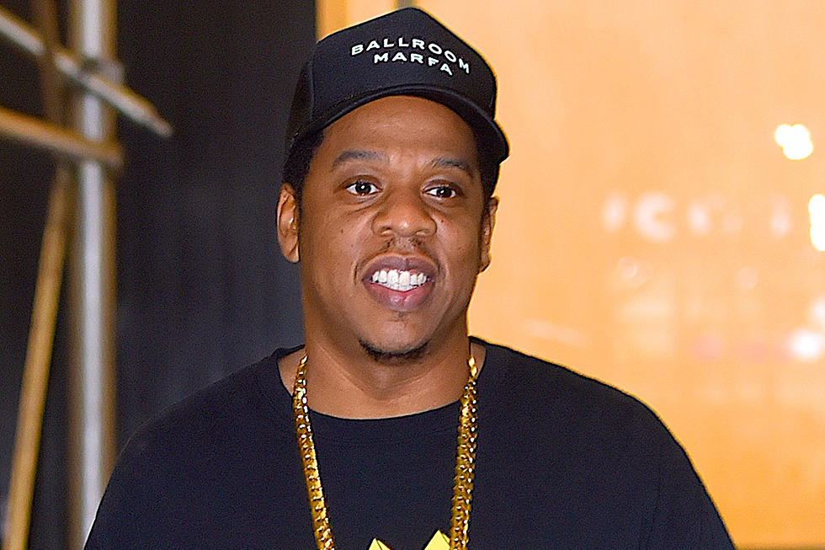

Interviewer: Your 13th album, 4:44, has been receiving rave reviews and one particular song in the album has been all over the internet, "The Story of OJ" the song is ultimately about racial discrimination and in recent times, it has been a trending subject, especially with Trump as the president. Why did you choose to use OJ Simpson's case for this song and not any other cases that have surfaced in the past year?

Jay Z: Yeah, yeah, yeah. I am really happy that people are paying attention to this song in particular and that it has kick started important discussions that we should be having now, especially now. Well, OJ simpson is a very well-known figure in America for the past few decades. He was an actor, NFL player, a broadcaster and used to be a role model to many Americans. However, today he is known for the crimes that he had committed. And the line “I’m not black. I’m OJ” that he said during his trial is something that many remember till today. It is very much related to the racial discrimination that is going on now. Regardless of your wealth and status, people would still associate you with your racial identity. OJ would be referred as Black or African American. But he refused to take pride in who he is and what kind of person he is referred as. He made that psychological damage and then cut all the ties. Every man should take pride in who they are. He is a great example of a person who is ashamed of his identity and his culture and especially cus he does not want to be referred as a black. And what other reasons do I need than that his actions were controversial and what he had said made a huge impact on the society, especially my people, the black community.

Interviewer: As much as the song has garnered good reviews it has also been surrounded by controversies. Jewish are unhappy with some lines in the song have accused it for having anti-semitic stereotype about Jews and money. How do you see this and what is your opinion about this?

Jay Z: Different people view this song differently, some may like it and some may not, depending on what and how they want to agree or disagree with my views. For instance this line in the song “You ever wonder why Jewish people own all the property in America? This is how they did it”. Some of them are not happy about it and I think they are hypocritical as it is what it is, what I’ve seen and learnt about in my life. I mean, my songs and the ideologies in them are largely influenced by my experiences and lessons learnt so, it is what it is. And yeah, definitely a Black American will view it differently from a White American. I am just trying to reduce racism by advocating it through my songs. There are black American stereotypes and Jewish stereotypes to bring up a point which are exaggerated and that’s what makes “ Story of O.J.” culturally relevant today. In the end, what matters is the deeper meaning of the song which is to fight racism.

Interviewer : As part of the follow up to the previous question, who are your actual target audience?

Jay Z: Everyone. A song about racial discrimination, everyone would have surely experienced it in their life before. But definitely the African Americans were my main target audience. The song is about us, African Americans. The rap is to tell them not to be ashamed of their identity and that they should take the pride of being Black.
We should bring something good out of what we have. I have criticised and talked about the flaws of the African Americans of not being money wise, no virtue of saving. Isn’t it why we have been stereotyped for doing drugs and partaking in illegal jobs to get rich quick. Even then we do not have a base and do not build on that money so, struggle financially. Those caught in this madness should be using the money for other uses ok. In addition, they do not do things to secure their financial position in the future as they lack the foresight. They look at the short term benefits of having money. I have addressed this through my lyrics
“Take your drug money and buy the neighbourhood; That’s how you rinse it; You wanna know what’s more important than throwin’ money at strip club? Credit”. African Americans are heavy borrowers too. They are still stuck in this low socioeconomic status due to their flaws, you know what I am saying.

Interview: In your answer, I could sense that you are keen in tackling racism in modern America. It was evident in the music video as well. What do you hope achieve with these song.

Jay Z: It is easy for people to distance themselves from the struggles the black community faces once you have reached a high enough level of wealth. the lyrics and the music video contrast the history of the black community today. It also emphasizes that there is still a type of slavery that exists. Financial slavery. According to the centre of global policy solutions, white households have a median wealth 20 times that of an African American household. Think about that. Depressing. System akin and social barriers has limited the African American community from upward economic mobility. The discrimination prevents them from getting hired so they settle for manual labour and service-sector jobs that have lower pay. They are unable to go to college due to low income. The lack of college education is caused by racial wealth gap. This cycle results in financial slavery. No amount of wealth can erase the history of this racism. In my song, I am just addressing their flaws, criticising their actions in hopes that they will change and improve.

Sources:

https://www.elitedaily.com/p/the-meaning-of-jay-zs-the-story-of-oj-is-all-about-racism-in-america-7999549

https://www.entitymag.com/jayz-the-story-of-oj/

https://www.biography.com/crime-figure/oj-simpson

https://afterlivesofslavery.wordpress.com/2018/04/13/the-story-of-o-j/

https://www.washingtonpost.com/news/early-lead/wp/2017/09/16/jay-z-dedicates-song-the-story-of-o-j-to-colin-kaepernick-at-nyc-music-festival/?noredirect=on&utm_term=.98967b06d075

https://www.theexecutivetea.com/culture/2017/7/19/unraveling-jay-zs-the-story-of-oj

www.youtube.com/watch?v=UMlqvCqfDrA

https://www.bustle.com/p/this-is-what-jay-z-had-to-say-about-oj-simpson-the-way-race-is-perceived-in-america-6752475

https://news.avclub.com/jay-z-opens-up-about-his-kanye-feud-and-the-story-of-o-1798346195

https://www.dandad.org/awards/professional/2018/music-videos/27091/the-story-of-oj/

https://www.baeblemusic.com/musicblog/7-7-2017/jay-zs-the-story-of-oj-is-clever-and-insightful.html

https://www.xxlmag.com/news/2017/12/jay-z-jaz-o-reunite-444-tour-chicago/

